Semiconductors: Intel Corporation (INTC)

FIN-351 Investment Fund and Security Analysis

Lee Vang

DeVry University Online

10/14/2012

Table of Contents
Introduction 3
Economic Analysis 4
Industry Analysis 5
Financial Analysis 6
Ratio Analysis 8
Technical Analysis 12
Graph 1 12
Recommendation 13
Conclusion 13
REFERENCE 14

Introduction
The semiconductor industry serves as an indicator of how much technology has progress. New developments in the industry determine the way we work, how we communicate, and how we entertain ourselves. Personal computers, cars, cell phones, iPods, PlayStation, Xbox, Wii, all use semiconductors. The semiconductor industry lives by the simple creed of smaller, faster and cheaper. New chips are packing more transistors and getting cheaper because of fierce competition and new technologies. In this industry, the Intel Corporation (INTC) dominates the world in the design and fabrication of semiconductor devices. Even though the United States industry faces regulations by the government and export quotas, the industry in the U.S. aims to lead globally in the commercialization of innovation which is critical to the U.S. national safety and the economy. However, the downturn of the economy indicates that the U.S. is no longer assured of being the world’s leader in the discovery of new commercial products. While the United States innovation system slowly erode through financial and policy support, the rest of the world is working to improve its’ capacity to generate new technologies and products, attract and grow existing industries, and build new positions in the high technology industries. Intel is facing tough competition.

Fundamental Analysis
Economic Analysis
The United States current fiscal policy is loose or expansionary; government spending is higher than revenue. The desired effect of the expansionary spending is to restore the output of goods and services, the gross domestic product, and more jobs. A great example of fiscal policy in action was the passing of the current President’s fiscal policy in 2009 Stimulus package which combine government and tax cuts to help consumers get some kind of relief, encourage spending, create employment, and stimulate business production (Economy 101, 2012).
The current monetary policy of the United States is low short-term interest rates known as the federal funds rate fell from 5 ¼ percent to nearly zero. During the recession of December 2007 to June 2009, Industrial production fell 17 percent and businesses were about two-thirds of their recovery production capacity. As far as unemployment goes, nearly 9 million jobs were lost and the employment rate rose from 5 percent to 10 percent. The focuses of the Federal Reserve were to establish programs to provide liquidity to financial markets and get credit flowing again. The Federal Reserve also lowered longer-term interest rates by purchasing $1.7 trillion worth of mortgage-backed securities, government agency debt, and Treasury securities (Current Issues in U.S. Monetary Policy, 2012). The current outlook for the U.S. economy is recovering at a gradual pace. The Gross Domestic Product, market value of final goods and services produced within the United States 2011 is at $15.094 trillion (Google Public Data, 2012). According to the Bureau of Labor Statistics, the employment rate decreased to 7.8 percent for September 2012 and a dramatic increase of employment in the health care, transportation, and warehousing industries (Employment Situation Summary, 2012). The pace of hiring seemed to have picked up which indicates the coming months there should be more growth. The Semiconductor Industry Association (SIA), representing U.S. leadership in semiconductor manufacturing and design, announced that worldwide sales of semiconductors reached $24.30 billion for the month of August 2012, a slight increase of 0.1 percent from the previous month when sales were $24.27 billion and a 3.2 percent decrease from the August 2011 total of $25.1 billion. Year-to-date sales reached $189.46 billion in August 2012, down 4.6 percent compared to the same time last year (Rosso, 2012). Stocks declined as the World Bank reduced its’ growth forecasts for East Asia and Pacific region because there were risks that the slowdown in China would last longer than originally forecasted (Mikolajczak, 2012).

Industry Analysis
The semiconductor industry is highly competitive due to other company’s advancements toward smaller chips containing more transistors at smaller size, cheaper price, and faster speed. The Semiconductor Industry Association estimates that around 54% of revenue came from the Asia/Pacific region (excluding Japan), followed by the Americas with an 18% share, Japan with 15% and Europe the remaining 13%. The computing business is being driven by Microsoft Corp’s Windows 7. Even with operating systems, such as Apple Inc.’s Macintosh platform gaining popularity, and cloud alternatives such as Google Inc.’s Chrome coming to market, Windows 7 adoption rates have been high. Apple’s success is also a big driver, since the Macintosh OS runs on Apple devices alone, which means more hardware and more semiconductor devices being sold. Also, increased computerization in emerging markets such as China, India, Brazil and Russia are also helping growth. The biggest driver of business is the growth in the data center segment, which has increased focus on servers, storage and networking equipment that consume semiconductors of the high-end variety. The cost advantages of moving to the cloud are encouraging many small and medium-sized businesses, as well as some large organizations to transfer either a part or the whole of their operations to the cloud. The semiconductor industry should also see growth due to the consumer electronics market which includes gadgets such as LCD TVs, Blu-ray players and smartphones. Communications infrastructure spending is currently being driven by China and India. The SIA expects infrastructure spending in these geographies to remain the major driver of semiconductor sales.
Medical Devices is an upcoming area and semiconductors targeted at this market are beginning to do well (Semiconductor Industry Outlook, 2012). Even with fierce competition, the industry should see growth.
Close This Panel X
Financial Analysis
Dividend Valuation Model
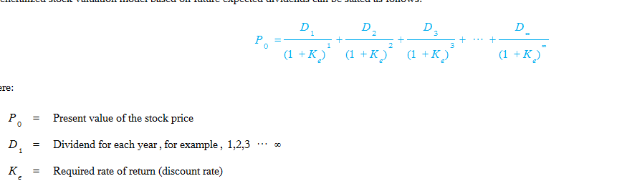
P₀= $21.76
D₁ ₌ Dividend for each year
K_{e}=13.47% (required rate of return)
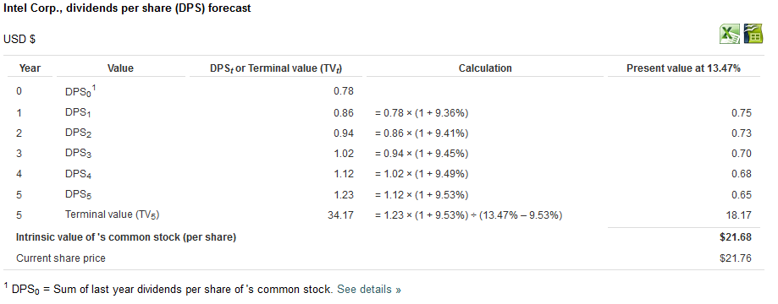
(Intel Corp. Dividend Discount Model, 2012)
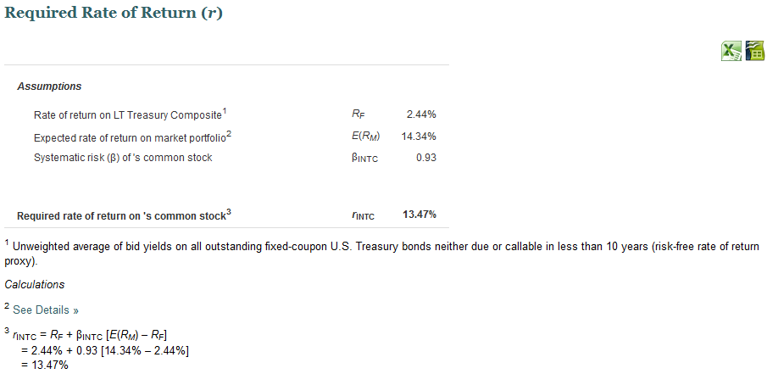
(Intel Corp. Dividend Discount Model, 2012)
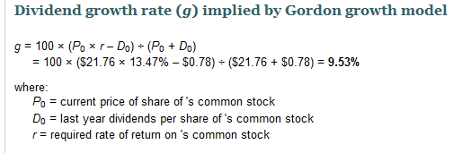
(Intel Corp. Dividend Discount Model, 2012)

According to Intel’s dividend valuation, the company has a required rate of return at 13.47 percent and its’ current stock price is $21.76 with Earnings per Share at $2.39.

Earnings Valuation Model
Present value of dividends for the next 2 years
Year | Estimated Earnings Per Share | Estimated Payout Ratio | Estimated Dividends per Share | Present Value Factor at K_{e} = 13.47% (13%) | Present Value of Cash Flows from Dividends
2012 | $2.39 | 33% (advfn.com, 2012) | $0.7887 | 0.885(APPENDIX D) | 0.698
2013 | 2.39*.0953=.227767+2.39=2.618 (Yahoo!Finance, 2012) | 33 | .864 | 1.668(APPENDIX D) | 1.441
Present Value of Estimated Dividends |  |  |  |  | =$2.139

P/E ratio
Terminal year | EPS | Estimated P/E ratio | Price₂₀₁₃ | PV factor | PV of 2012 stock price
2013 | $2.618 | 9.20 (advfn.com, 2012) | $24.09 | .783 | $18.86
Total PV at beginning of 2012 |  |  |  |  | =$21.00

Ratio Analysis
Intel’s Profitability ratios are Gross Profit Margin, After-Tax Profit Margin, Return on Assets, and Return on Equity. Intel’s Gross Profit Margin for the fiscal year ended December 31, 2011 was at 64.46 percent which means that for every dollar Intel spent on creating semiconductors, the company has $0.6446 left at the end of the day. The fiscal year 2010 Profit Margin for Intel was at 64.64 percent, a slight decrease in 2011 from 2010 (YCharts, 2012). The After-tax Profit Margin for Intel for the fiscal year ended December 2011 was at 24.20 percent compare to 2010 at 27.76 percent, more than a 3 percent decrease in After-Tax Profit Margin for 2011 (YCharts, 2012). Return on Assets for 2011 was at 19.3 percent and 2010 at 19.7 percent. Return on Equity for 2011 was 27.1 percent and 2010 was 25.2 percent. Return on Equity for Intel experienced an increase in 2011 compare to 2010 which indicated that Intel is generating profits from shareholder’s money (Morningstar, 2012). Intel’s Asset-utilization ratios are Receivables Turnover, Inventory Turnover, Fixed-Asset Turnover, and Total Asset Turnover. Intel’s Receivables Turnover ratio for 2011 was 14.79 compare to 2010’s ratio of 15.22. According to the decrease in the Receivables Turnover ratio, Intel’s efficiency in using the company’s assets deteriorated (Stock Analysis on the Net, 2012). The Inventory Turnover ratio for Intel for the year ended December 2011 was 13.18 and 2010 was 11.61, an improvement from 2010 (Stock Analysis on the Net, 2012). The Fixed-Asset Turnover ratio for 2011 was 2.29 and 2010 was 2.44, a slight decrease. The Total Asset Turnover for 2011 was 0.76 and 2010 was 0.69, an improvement (Stock Analysis on the Net, 2012). The Liquidity ratios for Intel are the Current Ratio, Quick Ratio, and Net working capital to total assets. The Current ratio for 2011 was 2.151 and for 2010 were 3.389. Intel reduced its Current ratio in 2011 (Intel Corporation Current Ratio, 2012). The Quick ratio in 2011 was 1.54 and 2010 was at 2.65. The Quick ratio for Intel deteriorated in 2011. The deterioration and low Quick ratio indicate that Intel’s is not in a good position on its ability to meet short-term obligations (Stock Analysis on the Net, 2012). The Net working capital to total assets for Intel in 2011 was 19.47. The positive ratio of 19.47 indicates that Intel is able to pay off its short-term liabilities. The Debt-utilization ratios for Intel are Long-term Debt to equity, Total Debt to Total Assets, Times Interest Earned, and Fixed Charge Coverage. The Long-term Debt to Equity ratio for Intel the year ended December 2011was 0.1597 and December 2010 was 0.0428. The Long-term Debt to Equity ratio indicate the relative proportion of shareholder’s equity and debt used to finance the company’s assets. The Long-term Debt to Equity ratio for Intel increased in 2011, which meant that Intel has been aggressive in financing growth with debt (Intel's Historical Debt to Equity Ratio, 2012). Total debt to total assets for Intel in 2011 and 2010 were 0.2 and 0.0 (Morningstar, 2012). Times interest earned for Intel for the fiscal year ended December 2011 and 2010 were not available online. The Price ratios for Intel are the Price to earnings, Price to book value, and Dividends to price (dividend yield). The Price to earnings ratio for Intel were 10.15 for the year ended December 2011 and 10.46 for the year ended December 2010. The Price to earnings ratio decreased in 2011 from 2010. The PE ratio shows current investor demand for a company share. The decreased in the PE ratio for Intel indicate that demand for the company had also decreased (Intel Corporation Current PE ratio, 2012). The Price to book value for Intel were 2.690 for 2011 and 2.372 for 2010. The Price to book value for Intel increased in 2011 indicating that the company’s stock is not undervalued and might not be as desirable to some investors (Intel Corporation Price/Book Value, 2012). Dividends to price for Intel were 3.23 percent for 2011 and 3.00 percent for 2010. The dividend yield for Intel increased in 2011 compare to the previous year (Intel Corporation Historical Dividend Yield Data, 2012). Other ratios that concern Intel are the Average tax rate and the Dividend payout ratio. According to data available through Intel’s Annual report website, Intel only indicated data for 2010 and 2009 which were most recent. The effective tax rate for Intel for 2010 was 28.6 percent and for 2009 at 23.4 percent. The higher tax percentage of profits for 2010 were generated from the company’s higher tax jurisdictions (Intel 2010 Annual Report, 2012). The Dividend payout ratio for Intel for the present time is at 33 percent (advfn.com, 2012). The industry norm for the net profit margin is 17.2 percent, return on equity stands at 23.5 percent for the industry currently for the year 2012. Intel’s return on equity performance is higher than the average industry; however Intel’s return on assets is below the industry norm at the current 15.7 percent. The asset-utilization ratio for the industry for receivables turnover is 7.32 percent for 2011 and 7.16 for 2010. Intel’s performance in the receivables turnover ratio is better than the industry but it deteriorated within the company from 2010 to 2011. Intel’s inventory turnover ratio improved in 2011 but is well below the industry norm of 20.18 for 2011. Intel’s ranks number 17th on its current ratio at 2.447 within the semiconductor industry-broadline, slightly below the industry average (Current Rankings for Semiconductor, 2012). Intel is performing well above the industry average for the debt to equity ratio. The price to book value for the industry for 2012 is at 4.1. Intel’s price to book value is below the industry average.

Technical Analysis

Graph 1
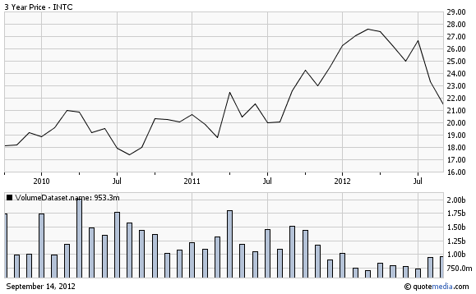
(Charts for Intel, 2012)
The graph above is showing a 3 year movement of Intel’s (INTC) stock and volume created at investorguide.com. The overall movement of the stock price for Intel has moving in a upper positive direction from 2010 to 2012, with certain periods of decreasing but the overall look of the graph indicate that the company is doing good. As of July 2012, the stock price has been decreasing and the average volume currently is at more than $40 million shares.

Recommendation
Conclusion
Unemployment rate has decreased, the stock market and the economy is doing better. Intel Corporation would be a good investment for many reasons. First, the semiconductor industry has increased sales of 54 percent and 18 percent of those sales came from America. As the computing business is dominated by the success of Microsoft and Apple, new hardware will demand more semiconductors. The industry will also see increased sales due to consumer demands for LCD, Blu-ray and Blue tooth technology. Computerizations in emerging markets will also contribute to the increasing sales and demand of semiconductors. Not only is Intel at the top of the semiconductor industry but the company has also been a fair performer in the past two years. Profit margins are down for the year 2011 from 2010 by a few percentages but return on equity experienced an increase in 2011. The company did not perform well in receivables turnover ratio, for the ratio decreased. However, the company did see improvement in its inventory turnover ratio, a 2 percent increase. Intel’s quick ratio indicated that the company will not be able to meet its short-term obligations when it is due. Intel also ranked 17th on its current ratio according to the industry at 2.447 which is better than ranking last but it is not as great as being first. As Graph 1 indicate, the decrease in Intel’s stock is not likely to continue. The stock price for Intel is falling but this decrease in the stock price might be due to other reasons besides the performance of the company. I’m going to be an optimist and recommend Intel. I believe the company will bounce back and it would be a good investment.

REFERENCE

advfn.com. (2012, 10 11). Retrieved from www.advfn.com: http://www.advfn.com/p.php?pid=financials&symbol=N^INTC
Charts for Intel. (2012, 10 14). Retrieved from www.investorguide.com: http://www.investorguide.com/stock-charts.php?ticker=INTC
Current Issues in U.S. Monetary Policy. (2012, 10 8). Retrieved from Federal Reserve of Cleveland: http://clevelandfed.org/For_the_Public/News_and_Media/Speeches/2011/Pianalto_20110407.cfm
Current Rankings for Semiconductor. (2012, 10 14). Retrieved from ycharts.com: http://ycharts.com/rankings/industries/Semiconductor%20-%20Broad%20Line/current_ratio
Economy 101. (2012, 10 8). Retrieved from Practical Money Skills: http://www.practicalmoneyskills.com/foreducators/econ101/20090710_fiscal_policy.php
Employment Situation Summary. (2012, 10 8). Retrieved from Bureau of Labor Statistics: http://www.bls.gov/news.release/empsit.nr0.htm
Google Public Data. (2012, 10 8). Retrieved from www.google.com: http://www.google.com/publicdata/explore?ds=d5bncppjof8f9_&met_y=ny_gdp_mktp_cd&idim=country:USA&dl=en&hl=en&q=gross+domestic+product
Intel 2010 Annual Report. (2012, 10 12). Retrieved from www.intc.com: http://www.intc.com/intelAR2010/mda/operations/provision_taxes/index.html
Intel Corp. Dividend Discount Model. (2012, 10 11). Retrieved from Stock Analysis on Net: http://www.stock-analysis-on.net/NYSE/Company/Intel-Corp/DCF/DDM#r
Intel Corp. Investor Kit. (2012, 10 11). Retrieved from www.companyspotlight.com: http://www.companyspotlight.com/viewer/28189
Intel Corporation Current PE ratio. (2012, 10 11). Retrieved from ycharts.com: http://ycharts.com/companies/INTC/pe_ratio
Intel Corporation Current Ratio. (2012, 10 11). Retrieved from ycharts.com: http://ycharts.com/companies/INTC/current_ratio
Intel Corporation Historical Dividend Yield Data. (2012, 10 12). Retrieved from ycharts.com: http://ycharts.com/companies/INTC/dividend_yield
Intel Corporation Price/Book Value. (2012, 10 12). Retrieved from ycharts.com: http://ycharts.com/companies/INTC/price_to_book_value
Intel's Historical Debt to Equity Ratio. (2012, 10 11). Retrieved from ycharts.com: http://ycharts.com/companies/INTC/debt_equity_ratio
Morningstar. (2012, 10 12). Retrieved from quicktake.morningstar.com: http://quicktake.morningstar.com/stocknet/mstockgrades.aspx?symbol=intc
Semiconductor Industry Outlook. (2012, 10 8). Retrieved from Zack's Investment Research: http://www.zacks.com/stock/news/51665/semiconductor-industry-outlook-apr-2011
Stock Analysis on the Net. (2012, 10 11). Retrieved from www.stock-analysis-on.net: http://www.stock-analysis-on.net/NYSE/Company/Intel-Corp/Ratios/Short-term-Operating-Activity#Receivables-Turnover
Yahoo!Finance. (2012, 10 11). Retrieved from finance.yahoo.com: http://finance.yahoo.com/q/ae?s=INTC+Analyst+Estimates
YCharts. (2012, 10 12). Retrieved from ycharts.com: http://ycharts.com/companies/INTC/gross_profit_margin
Mikolajczak, C. (2012, 10 8). Wall Street Falls at open after World Bank's Asia Outlook. Retrieved from Yahoo! News: http://news.yahoo.com/stock-index-futures-signal-early-losses-085538762--finance.html
Rosso, D. (2012, 10 8). Global Semiconductor Sales Remain Flat in August. Retrieved from Semiconductor Industry Association: http://www.sia-online.org/news/2012/10/02/global_sales_report_2012/global_semiconductor_sales_remain_flat_in_august/

